
Republic of the Philippines
Province of Tarlac
Municipality of Camiling
LOCAL YOUTH DEVELOPMENT OFFICE
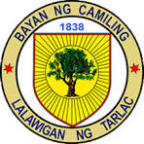
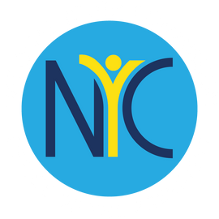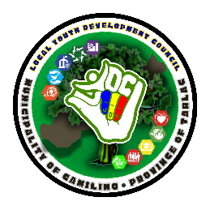

NATIONAL YOUTH COMMISSION

YORP Registration
A Complete Step-by-Step Guide
For Youth Organizations (YO) and Youth-Serving Organizations (YSO) applying through the Youth Organization Registration Program

10 Steps | 1–6 Days | 3-Year Validity | Free to Join



Gather these files before you begin — most are downloadable as templates from the YORP Portal (yorpnyc.org.ph).
- Registration Form — required *
- Directory of Officers / Adviser — required *
- List of Members in Good Standing — required *, must be in Excel format
- Constitution and By-Laws — required *
- Endorsement Letter — from your Local Youth Development Office or appropriate authority

NOTE Items marked * have downloadable templates on the YORP Portal at yorpnyc.org.ph. Each file must be under 1MB and in PDF format, except the membership list (Excel).

Which way do you register?
- City, Provincial, or Inter-Regional level: coordinate with your Local Youth Development Office (LYDO) first.
- Regional, National, or Consortiums/Federations: register directly with NYC at yorpnyc.org.ph/register.php — this is the process detailed step-by-step in this guide.
- LYDO staff: request an account at yorpnyc.org.ph by clicking "Request LYDO Account" under the YORP tab.

Step 1 of 10
Verify Your Email


- Go to yorpnyc.org.ph/yorppanel/Regcon/Verify
- Enter your organization's official email address — not a personal one.
- Type the Captcha code shown, or click "Random" to generate a new one.
- Click Submit.

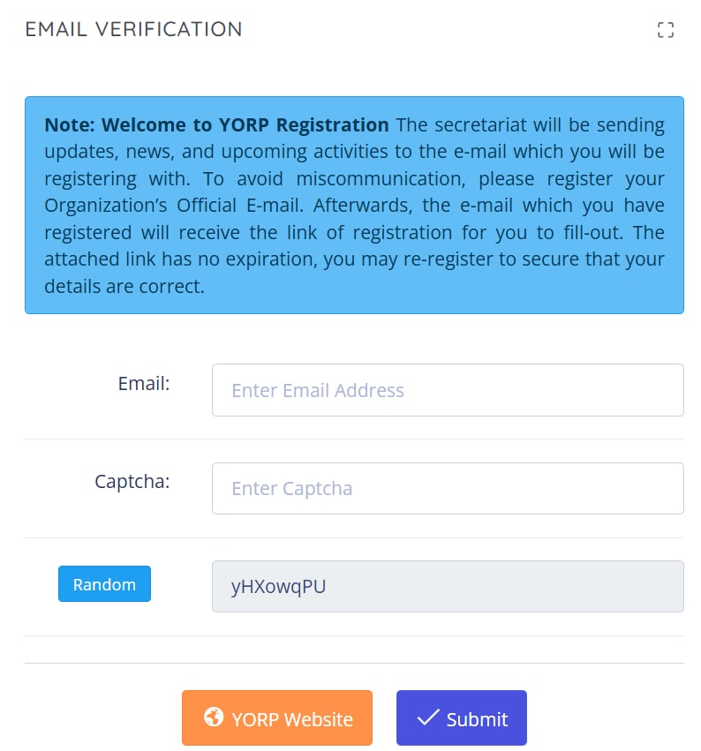

NOTE Use an email your organization checks regularly. The Secretariat sends all updates, news, and the registration link to this address, and it has no expiration if you need to re-register.

Step 2 of 10
Open the Registration Link

- Check the inbox of the email you just submitted.
- Look for a message from yorp@nyc.gov.ph, subject "NYC YORP Panel Web System."
- Click HERE! inside the email to open the registration form.

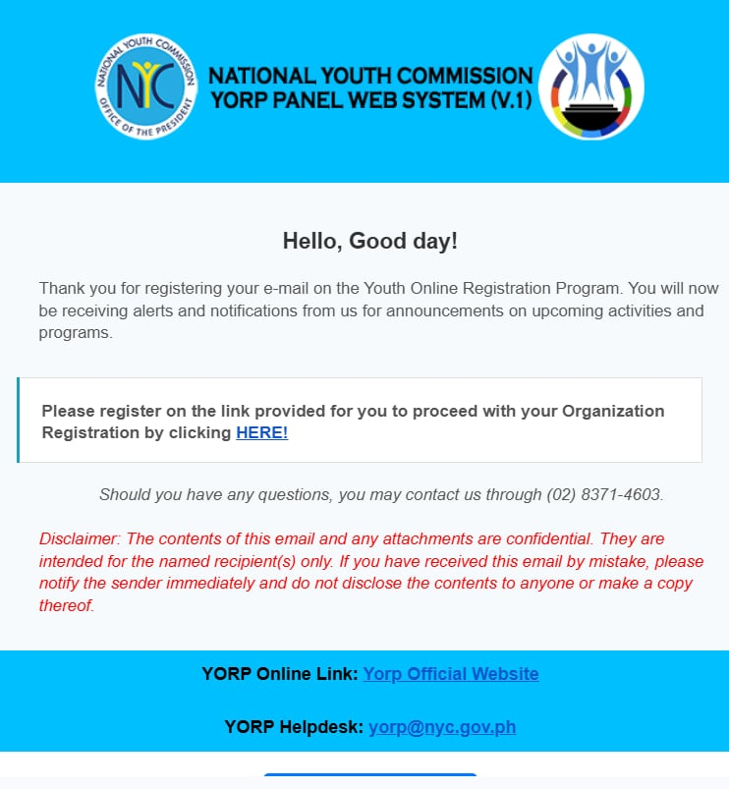

NOTE No email after a few minutes? Check your spam folder first, then re-do Step 1 with the correct address. You can also call (02) 8371-4603 for help.

Step 3 of 10
Organization Profile

This is Step 1 of 5 on the registration form.
- Fill in: Name of Organization, Complete Address, Telephone Number, Cellphone Number, Number of Members, and Date Established.
- Select your location: Island, Region, Province, Municipality, and Barangay.
- Select your Major Classification, Sub-Classification, and Organization Level.
- Choose your PYDP Center — you may select more than one.
- Write a Brief Description and Objectives of your organization.
- Click Next to continue.

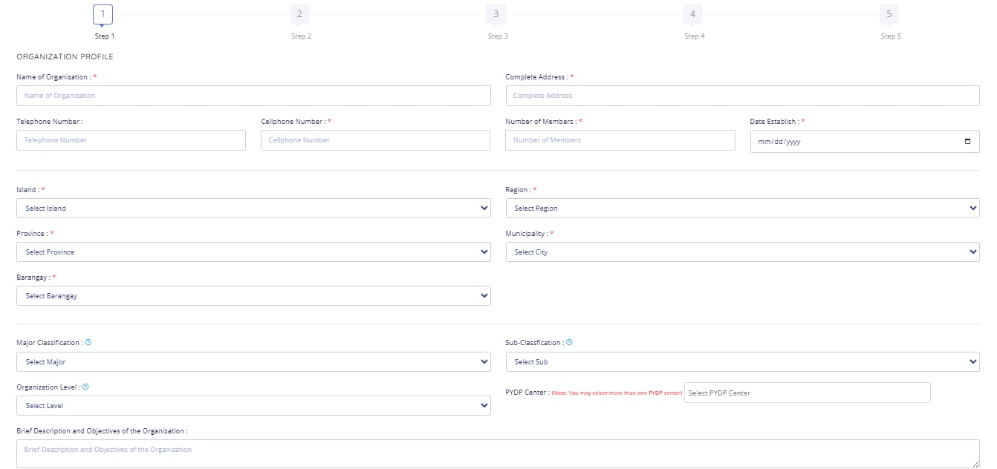

NOTE All fields marked with a red asterisk are required — the form won't let you proceed without them.

Step 4 of 10
Leadership & Membership Info


This is Step 2 of 5 on the registration form.
- Head of Organization (required): Family Name, Given Name, Middle Name, Contact Number, Email Address.
- Adviser of the Organization (optional): same fields, if applicable.
- Click Next.

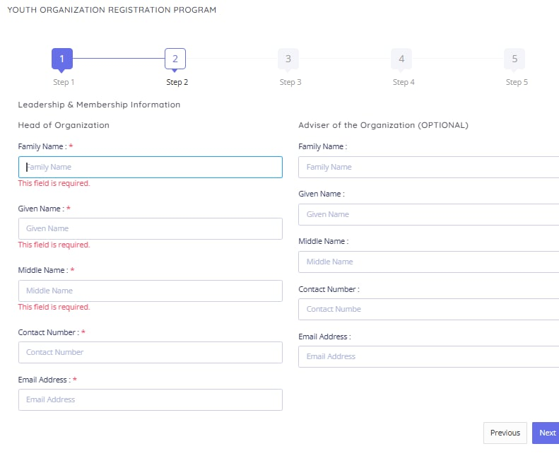

NOTE Use the Head of Organization's direct contact details — the Secretariat may reach out to this person to verify your application.

Step 5 of 10
Upload Your Documents

This is Step 3 of 5 on the registration form.
- Required: Registration Form, Directory of Officers & Advisers, List of Members in Good Standing, Constitution and By-Laws, and Endorsement/Certification/Resolution from Appropriate Authority.
- If applicable: Certificate of Registration to a Multi-level Organization, Certificate of Member Organizations, Local Youth Development Office Certification.
- Click Next once every required file is attached.

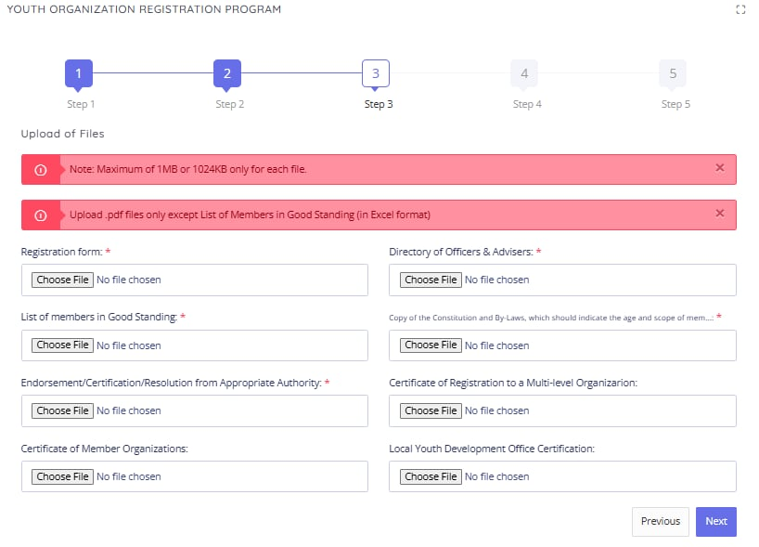

NOTE Each file must be under 1MB (1024KB) and in PDF format — except the List of Members in Good Standing, which must be an Excel file.

Step 6 of 10
Consent & Survey


This is Step 4 of 5 on the registration form.
- Read the consent statement carefully — by registering under RA 8044 and RA 10742, you confirm your information is true, consent to it being published in the official YORP registry, and authorize NYC to process it.
- You also confirm you've read the 2017 YORP Guidelines and understand that violations may lead to suspension or revocation of registration.
- Answer: "What trainings are you interested to attend?"
- Answer: "How did you know about YORP?"
- Click Next.
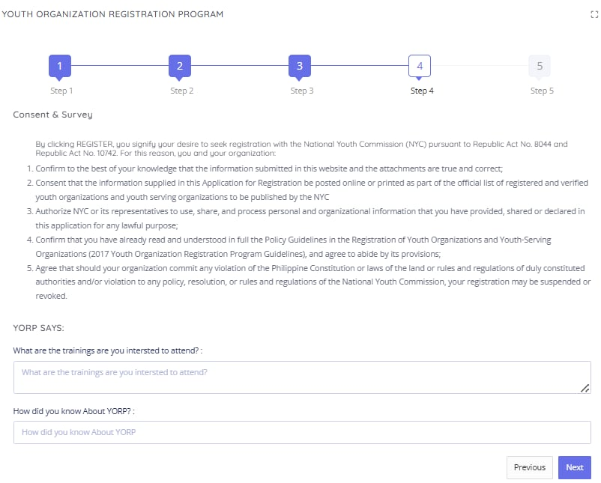

NOTE Take a moment on the consent text — this is the legal basis for your registration and how your data will be used.

Step 7 of 10
Feedback Survey & Submit

This is Step 5 of 5 — the final step of the online form.
- Optional: take the NYC Service Feedback Survey (about 3–5 minutes) to help improve the process.
- Click Submit to send in your completed application.

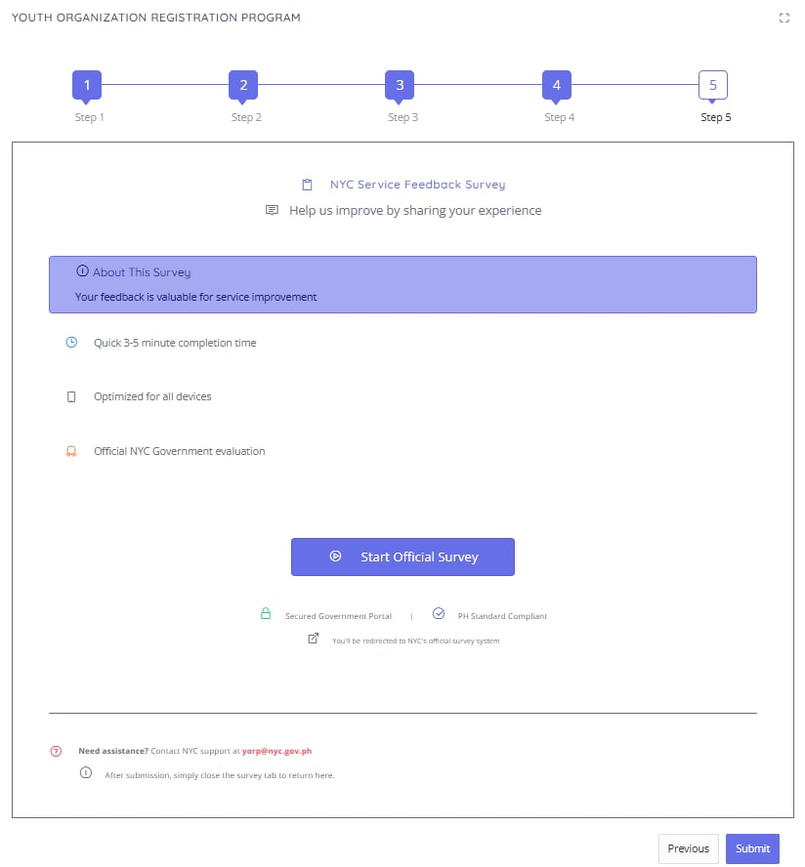

NOTE After submitting, you can simply close the survey tab and return — your application has already been sent.

Step 8 of 10
Wait for Confirmation & Verification


- Check the email you registered with for a confirmation that your application was received.
- The YORP Secretariat may contact your organization's officers or members directly to verify the information you submitted.
- Standard processing time is 1–6 days.
- If a document is missing or deficient, you'll receive a Notice of Denial / Request to Submit Missing Documents by email — you must comply within 10 days, or the application is forfeited.

NOTE Didn't get a confirmation email even though you submitted everything? The email address you registered may be incorrect — register again, or email yorp@nyc.gov.ph for assistance.

Step 9 of 10
Registration Approved — Access Your Account

- Once your organization meets all requirements, you'll receive a second confirmation email stating your registration is successful.
- This email includes your username and password for the YORP portal.
- Log in to the portal via Organization → Log In using those credentials.
- From there you can view your organization's profile, update your information, and check your status in the national registry.

NOTE New registrations are endorsed by batch to the Commission Proper for a Resolution. Your e-certificate is released by email once that resolution is signed.



Step 10 of 10
Post-Registration: Stay Compliant & Renew

- Annual reports: submit yearly accomplishment reports and keep your organizational information updated through the YORP portal.
- Renewal: your registration certificate is valid for 3 years. File for renewal with the required documents before it expires.
- Maintain compliance: avoid violations such as not submitting reports, misusing the NYC name or symbols, or participation in illegal acts — these can lead to suspension or revocation.
- Local recognition: your LYDO may issue a separate local registration certificate once local verification is complete, and docket your organization in the local registry.

NOTE Keep your login and certificate on hand — you'll need them for both annual reporting and renewal.

Good to Know
Your URN & the YORP Advisory


Unique Registration Number (URN)
- YO-prefix — for a Youth Organization or youth-led organization with members aged 15–30.
- YSO-prefix — for a Youth-Serving Organization, or one with youth as its major beneficiary.

Requesting a YORP Advisory
A YORP Advisory is a document you can request once registered, promoting or endorsing your organization's activities and events. It's signed by the Chairperson and CEO.
- Request it by emailing yorp@nyc.gov.ph with the details of your program or event.

Member Benefits
- Free training exclusively for YORP members.
- Use of the official YORP Seal/Logo in your collaterals, communications, and publications.
- Priority selection as representatives for youth consultations, NYC events, and international programs.
- Eligibility to request an endorsement from NYC through a YORP Advisory.
- Participation in your respective Local Youth Development Council (LYDC).

Need Help?
Contact the LYDC Officer


- Email: localyouthdevtofficecamiling@gmail.com
- Facebook: SK Camiling

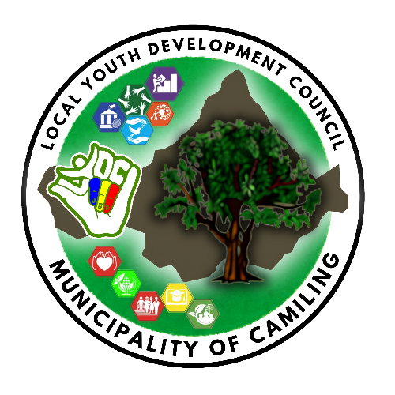
Youth Organization Registration Program
National Youth Commission

